SEND Profile of Need – (Spring 2023)
Whole School SEND  INFANTS  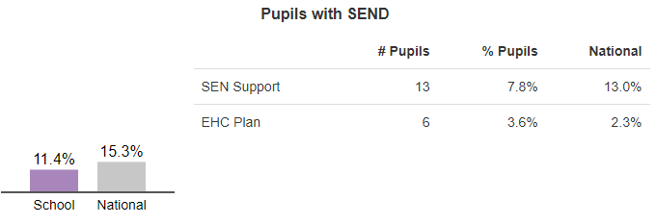  JUNIORS  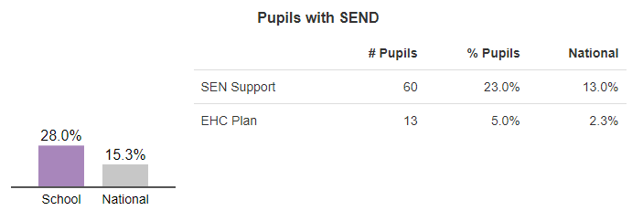 | Broad Areas of Need
Pupil Premium/ SEND/EAL  Whole School PP SEND/PP SEND/EAL  Infants 56.4% 9.32% 0  Juniors 62.2% 28.5% 0 | Categories of Need  ADHD ASD MLD PD SLCN VI/HI  YR 25% 75%  Y1 11% 23% 11% 55%  Y2 40% 10% 50%  Y3 8% 33% 42% 17%  Y4 14% 28% 21% 36%  Y5 17% 23% 30% 24% 6%  Y6 4.5% 21% 47% 4.5% 17% 4.5%
Strengths and Areas for Development  Our Key Strengths – ‘Clear vision for the strategic direction in relation to SEND’, ‘inclusive school ethos’, teachers are committed to meeting the needs of all pupils’, ‘teachers are well supported by a team of support staff and ‘pupils appear happy at school, enjoy their learning and engage with activities.’ (SEND Review, Jan 22)  How do we know?  - SEND Review (Jan 22))  - Monitoring Visits (HIAS) (Jan 22)  - Monitoring Visits (LLP, Jan 22, Jun 22)  - Book Looks and Learning Walks (Dec 22)  - SEND Action Plan – latest review Jan 23 | Analysis  Information gathered from Graduated Response information and Nursery School transition meeting notes/ observations/parents consultations.  Lower than average in the Infant school reflects a school work on the Graduated Approach and Identification of Need – reviewed termly, focusing upon the children at Stage 3 of Graduated Approach – Intensive targeted support.  A higher percentage in the juniors is on the decrease in light of Graduated Approach but historic recording and parent confidence has meant that in Year 5 and 6 there are children who remain on the register who should be at Stage 3 rather than stage 4.  A new PLP format was introduced concentrating upon Strengths, Needs, High Quality Inclusive Teaching Strategies and Outcomes. A new identification Of Concerns system was introduced as part of the Assess, Plan, Do Review cycle.  The table above includes significant pupils reflecting co-morbidity. Due to our high level of need across both schools for SEMH, a significant percentage of our SEND budget is channelled in this area including Thrive Practitioner, small group Alternative Provision 5x ELSAs and 2 Counsellors, Oarsome Chance, Equine therapy.  Our areas for development in SEND  - Correct identification of need and targeted intervention.  - Implementation of a robust APDR cycle through HQIT&S  - Interrogation and data analysis to inform provision

