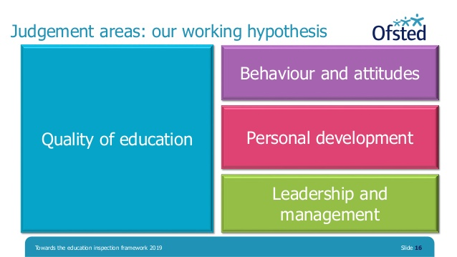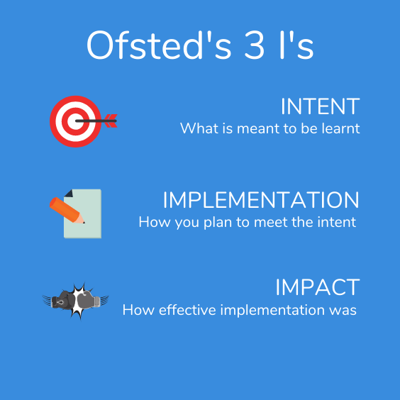**Governor Monitoring Visit**

**Schedule**

To be conducted in accordance with the **GB monitoring visits policy.**

To improve the effectiveness of Governor school monitoring, the below table centrally records key priorities to be monitored. Monitoring to be aligned to the key priorities in the **School Improvement Plan (SIP)** as informed by the Whole School Self-Evaluation document (SEF).

In addition, it is essential that governors plan to monitor *statutory obligations* with respect to Safeguarding, Health & Safety and the school’s use of funding.

**Term: Spring Term**

|  |  |  |  |  |  |  |
| --- | --- | --- | --- | --- | --- | --- |
| **SIP Key Priority Heading & Objective** | **Proposed Monitoring Visit**  **and with Who/How/Format?** | **Purpose of Visit – What do we wish to find out?** | **Governor?** | **When?** | **Report Completed (Y/N) & Outcome/Follow Up/Impact?** | **Triangulation?**  **Other Evidence to be considered?** |
| Teaching & Learning |  |  |  |  |  |  |
| Curriculum  Development  /Impact |  |  |  |  |  |  |
| SEND/Inclusion |  |  |  |  |  |  |
| Leadership |  |  |  |  |  |  |
| Safeguarding/H&S |  |  |  |  |  |  |
| Staff Development/ CPD/Staff Welfare |  |  |  |  |  |  |
| Attendance |  |  |  |  |  |  |
| Personal Development/Behaviour |  |  |  |  |  |  |
| Finance/Resources |  |  |  |  |  |  |

Internal Evidence Governor Monitoring Visit

External Evidence

Governors should consider **INTENT**: What is it that we are trying to achieve with respect to school improvement priorities?

**IMPLEMENTATION** – Are the actions in our SIP being implemented and on time?

**IMPACT** – What impact are these actions having on pupil provision and outcomes? **How do we know? Evidence?**

On planning monitoring activities, governors should remain mindful of actions identified from Ofsted and LLP/HIAS visits, in addition to SIP priorities (informed by the SEF).

**\*H&S monitoring to be conducted by H&S Governor and Site Manager(s) in usual manner – reporting back to the FGB.**

**\*\*Foundation subject monitoring (curriculum development, delivery, progress) to be undertaken in FGB meetings (invitations to subject leads).**